Text Length and Lines

Look at this code:
message = input("Short message: ")
character_count = len(message)
print("Message:\n" + message)
print("Characters:", character_count)

What do you think this code will display?
Click or tap here to enter text.

Run the code. Compare the result with your prediction:
Click or tap here to enter text.

Let’s investigate! Answer the questions below:
- For the input Code now!, what number is stored in character_count, and which space or punctuation marks are included?
Click or tap here to enter text.

- Why does the two-character sequence \n create a new line inside a string instead of appearing as two printed characters?
Click or tap here to enter text.

- For the input Code now!, what appears on the line after Message:?
Click or tap here to enter text.

Click or tap here to enter text.

Text Length and Lines

Look at this code:
message = input("Short message: ")
character_count = len(message)
print("Message:\n" + message)
print("Characters:", character_count)

Use the code above to help you. After completing each challenge below, run your program to test that it works correctly. Save each completed challenge program in a new file.

Programming Challenges

Challenge 1
Change the heading to "Notice:" while keeping the message on the following line. Code now must still report 8 characters.
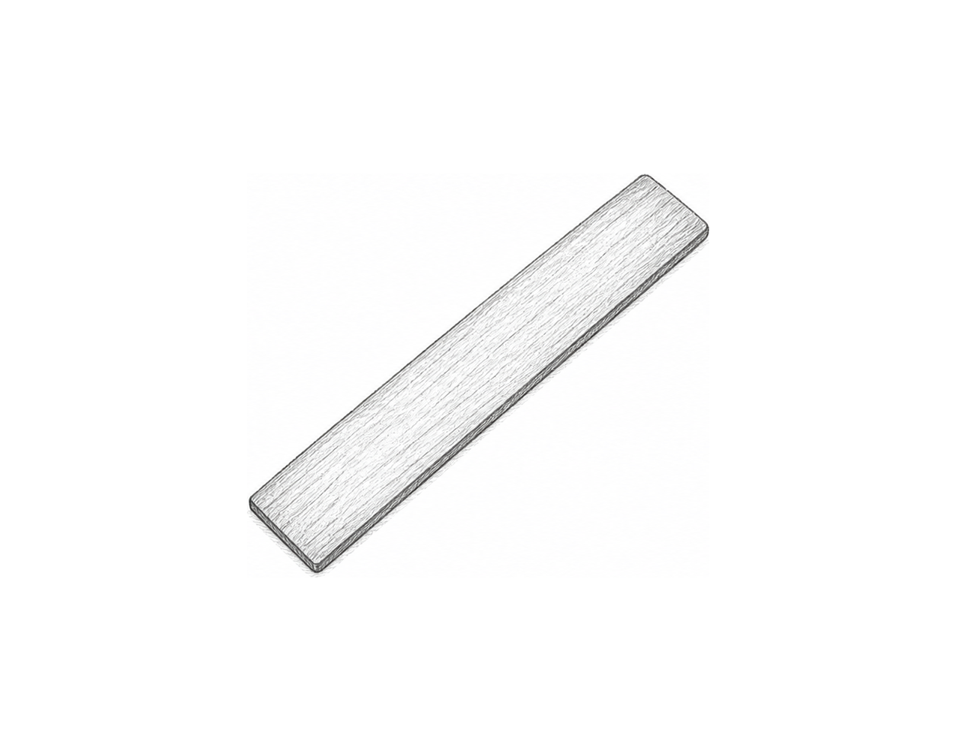

Challenge 2
Collect a title and a subtitle. Display both on separate lines, then display a labelled character count for each one.

Challenge 3
Create a two-line poster checker. Ask for a heading and one instruction, display the poster on two lines, and report the combined character count using the two len() results.

Text Length and Lines

Fix the code!

This code has errors! Look closely at the code to find the problems:

message = input("Short message: ")
character_count = len message
print("Message:"
+ message)
print("Characters:", character_count)

Rewrite the whole program in the box below with fixes to the errors.
Click or tap here to enter text.

After you are confident that you fixed all the errors, copy the code from the box and run it.

Did it work correctly on your first try? Did you find all the errors?
Click or tap here to enter text.

